
AI-Powered Semantic Email Threat Analyzer
Multi-Model Deep Learning System for Digital Forensics

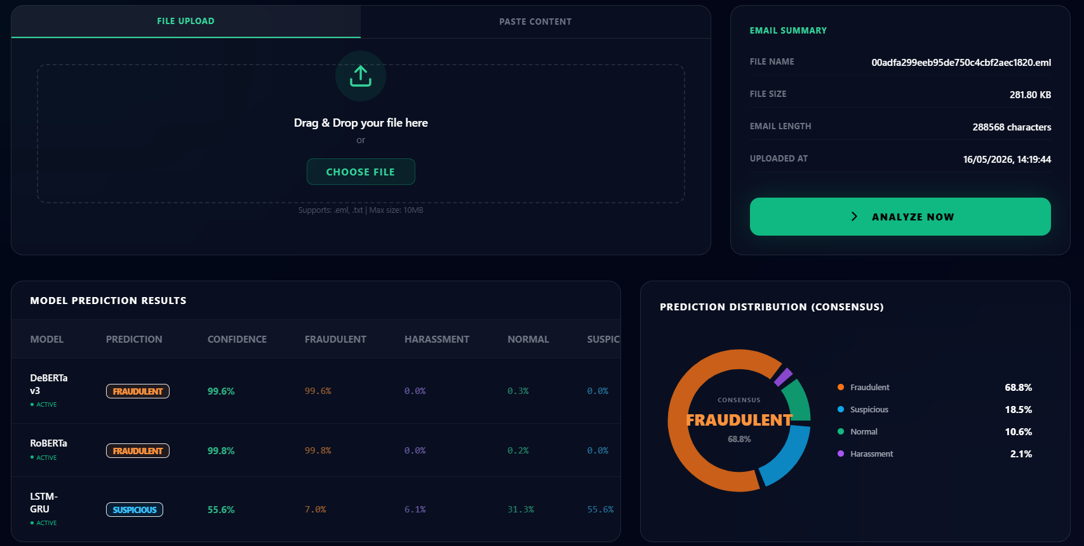
Real-Time AI Threat Detection Dashboard

Problem statement:
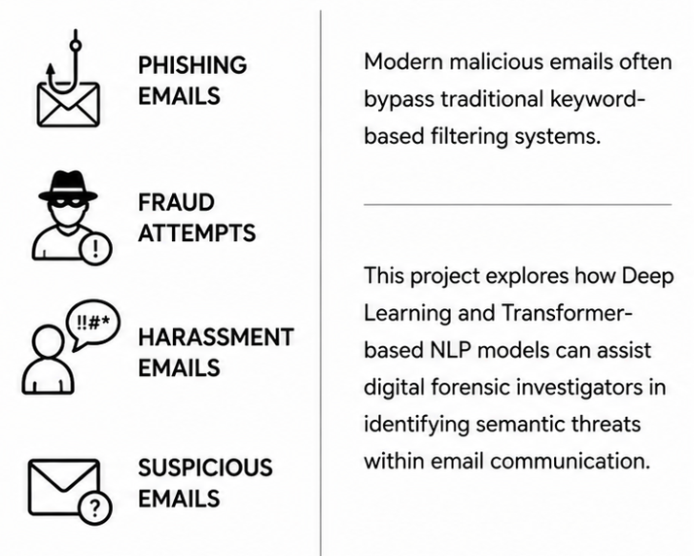
Gap & Novelty:
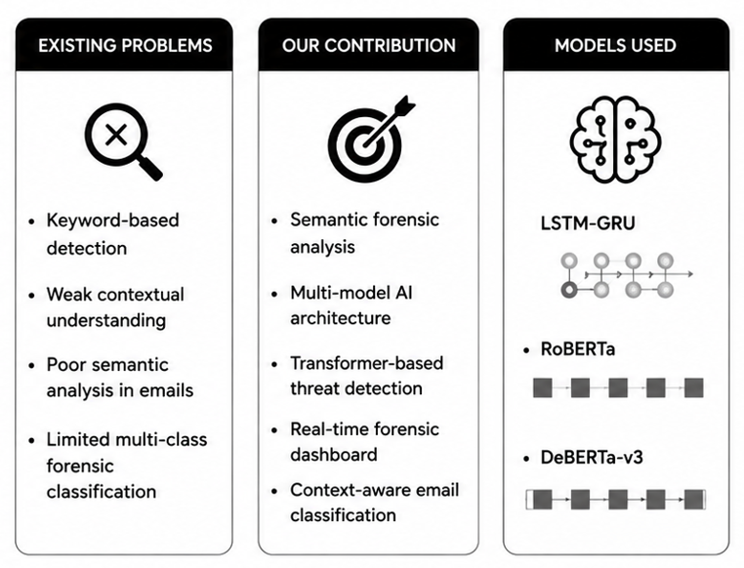

Architecture Diagram
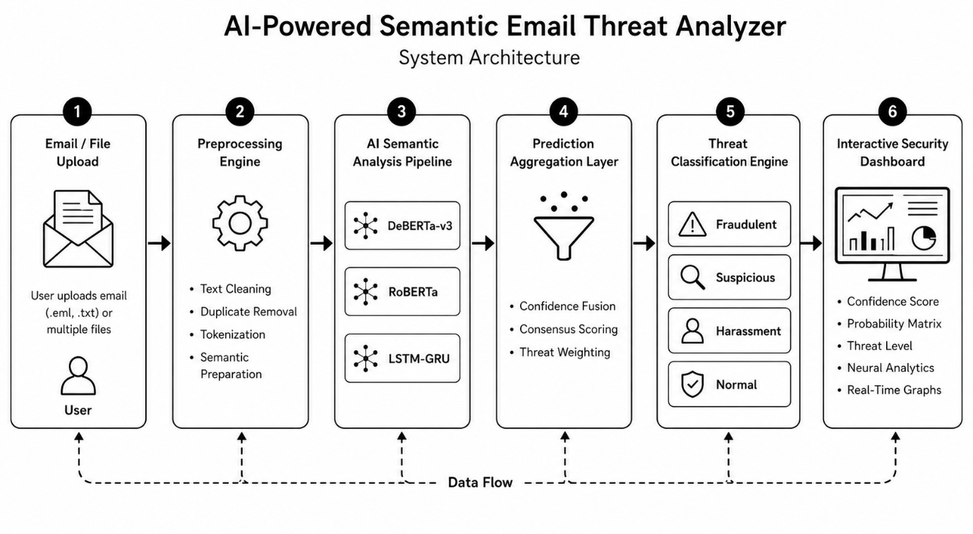
Dataset & EDA:
EDA revealed a significant class imbalance within the dataset. Harassment emails constituted the majority class with 19,190 entries, followed by Normal (6,616), Fraudulent (4,054), and Suspicious (3,206). This imbalance posed a challenge for model training and evaluation, particularly in achieving fair performance across minority classes.
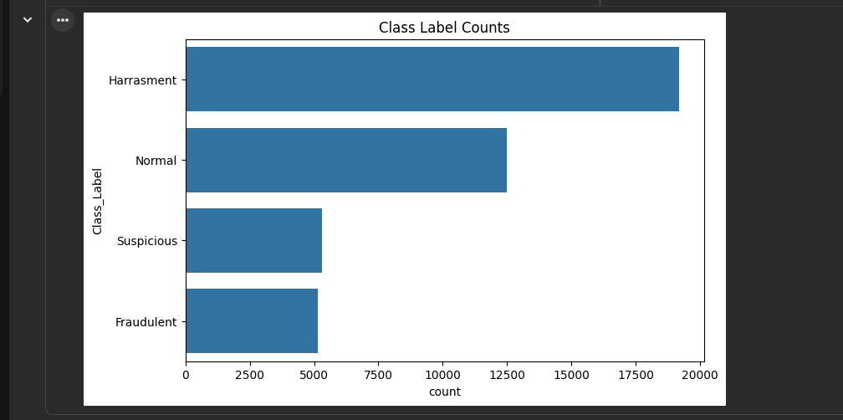

Confusion Matrix
DeBERTa confusion matrix:
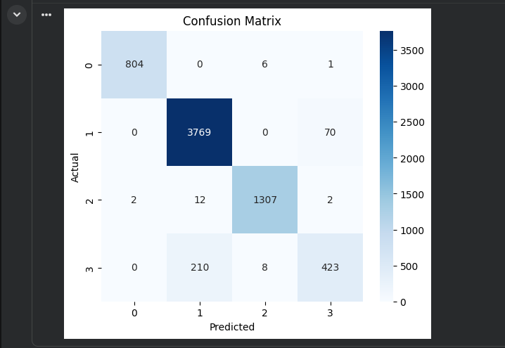
The confusion matrix demonstrates strong semantic discrimination across forensic categories.
DeBERTa-v3 achieved highly accurate classification performance with minimal class-wise misclassification, particularly in distinguishing Fraudulent and Normal email patterns.

LSTM–GRU Hybrid Model:
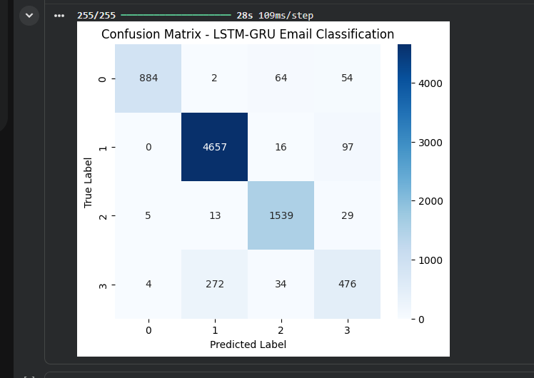

RoBERTa Base Model:
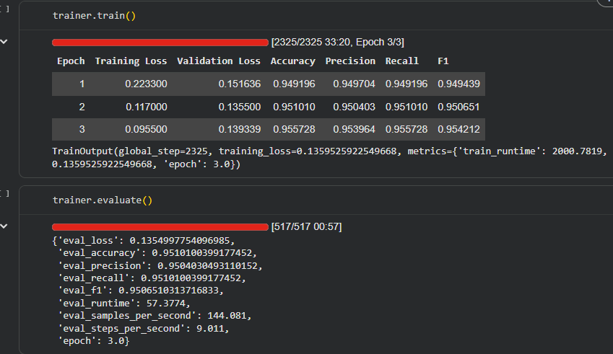
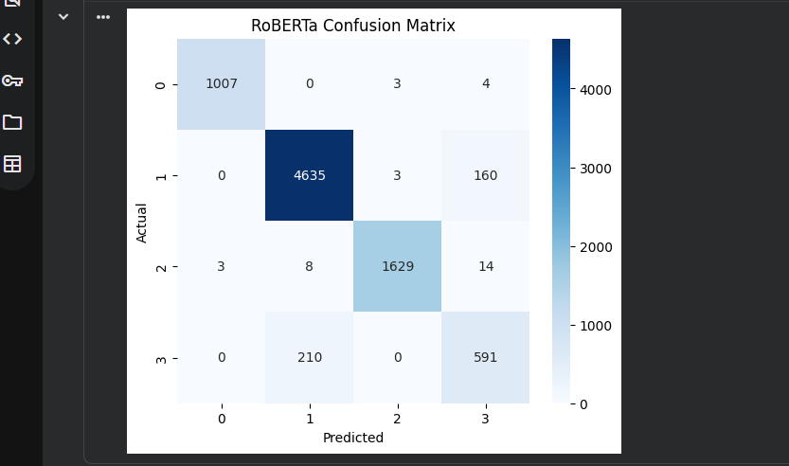

Model Comparison:

Metric | LSTM-GRU | RoBERTa | DeBERTa-v3
Accuracy | 92.76% | 95.10% | 95.30%
F1-Score | 0.93 | 0.9507 | 0.9506
Training Time | ~500s/epoch | ~33 mins | ~43 mins

LSTM–GRU Performance Analysis
- Accuracy: 92.76%
- Weighted F1-Score: 0.93
The model performed well on the majority Harassment class (precision: 0.94, recall: 0.98) but showed reduced effectiveness on the Suspicious class (precision: 0.73, recall: 0.61).
This limitation highlights the difficulty of capturing long-range dependencies in lengthy forensic emails using recurrent architectures.

RoBERTa Performance Analysis
- Accuracy: 95.10%
- F1-Score: 0.9507
RoBERTa demonstrated improved generalization across all classes, successfully classifying a large number of forensic-relevant instances.
The confusion matrix indicates strong semantic discrimination, particularly in separating Fraudulent and Normal emails.

DeBERTa-v3 Performance Analysis
- Accuracy: 95.30%
- Weighted F1-Score: 0.9506
- Final Evaluation Loss: 0.1402
DeBERTa-v3 achieved the best overall performance. Its disentangled attention mechanism enabled more precise interpretation of nuanced language patterns commonly found in forensic evidence.

Transformer-based models significantly outperformed recurrent architectures in semantic forensic email analysis.

Live Dashboard:

This dashboard screenshot showing probability matrix, graphs, confidence:
